An analysis on the 2014 Sony Pictures Cyberattack

Jack Peduzzi
Department of Cybersecurity , Mercyhurst University
CIS 401: Cyber Threat Intelligence
Professor Polachek

Executive Summary

Details
This paper will discuss the timeline of the attack, including the start, exfiltration of data, detection of the adversaries, the role of the Federal Bureau of Investigation, the damages caused by the attack, and what Sony could have done to prevent it. Financial data and graphical data will also be used to highlight the financial impact of the attack as well as the public reception of Sony Pictures.
Background
The 2014 Sony Pictures attack conducted by the North Korean government was in response to the film, The Dictator, which parodied North Korean leader Kim Jong Un. The attack was carried out using malware named Wiper, which was able to infect Sony’s network after hackers sent spear-phishing emails to workers. The emails that were sent were masqueraded as legitimate Apple ID reset emails and redirected the victim to a spoofed Apple website. Since some employees reused passwords, attackers were able to gain access to Sony’s network. The Federal Bureau of Investigation was called in to investigate the incident. They concluded that through their methods of analyzing malware, forensic investigation, and discovering attack vectors, the North Korean government was behind the attack. The attack caused a large amount of financial damage to the company, which was over 15 million USD.
Prevention
The devastating attack could have been prevented by Sony if they conducted proper employee training, such as identifying phishing emails, utilizing multi-factor authentication, not reusing passwords, and properly encrypting stored data.
The Trailer
In 2014, Sony Pictures was slated to release the film The Interview. The film was a comedy about two American journalists recruited by the CIA to assassinate North Korean Dictator Kim Jong-Un (IMDb, 2014). Earlier in the year, after the initial teasers were released for the film, the North Korean Government was outraged. A North Korean spokesman told the KCNA that, “Making and releasing a movie on a plot to hurt our top-level leadership is the most blatant act of terrorism and war and will absolutely not be tolerated. (BBC News, 2014)” The spokesman also added that, “If the US administration allows and defends the showing of the film, a merciless counter-measure will be taken (BBC News, 2014).” The spokesman’s comment about a counter-measure became increasingly clear as the year ended.
The Hack
On November 24th, Sony employees logged into their work computers and were greeted with a chilling image of glowing, red skeletons on their screens. The text on the screens read, “If you don’t obey us, we’ll release data shown below to the world. Determine what will you do November the 24th, 11:00 PM (GMT).” Below the message were five links that contained internal Sony Pictures data (Los Angeles Times, 2014). The information that was leaked was massive, with a size of over 100 terabytes. The information included passwords, social security numbers, internal emails, and even unreleased films. The malware was referred to as Wiper and had the sole intention of destroying and harvesting data. According to CrowdStrike (2023), “wiper attacks are a form of malware engineered to destroy or corrupt data on targeted systems. Wiper attacks are unlike ransomware, which encrypts data for ransom”. The malware is able to infect computers through multiple avenues such as phishing links, malicious downloads, and malicious attachments.
Figure 1
Image from Sony employee computers
Note. Adapted from Wired (2014). https://www.wired.com/2014/12/sony-hack-what-we-know/

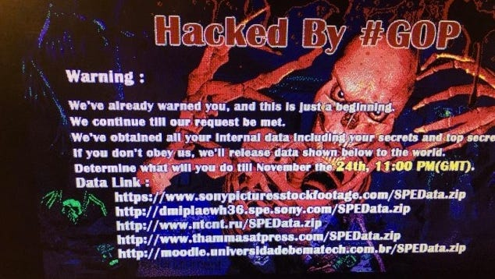
Private Sector and Government Involvement
On December 1st, 2014, Sony enlisted the help of Mandiant, which was part of FireEye at the time, as well as the FBI (Los Angeles Times, 2014). Just a day later, Sony executives Michael Lynton and Amy Pascal came out with a statement. They stated in a memo to Sony employees that, “while we are not yet sure of the full scope of information that the attackers have or might release, we unfortunately have to ask you to assume that information about you in the possession of the company might be in their possession.” They also outlined steps that employees could take to protect their identities. “We told you that we are offering all employees identity protection services with a third-party service provider, AllClear ID, and that you would receive an email tomorrow outlining steps to sign up.” In the coming days, these groups and Sony continued to investigate the incident. On December 5th, Sony employees received a threatening email that said, “Please sign your name to object the false (sic) of the company at the email address below if you don’t want to suffer damage. If you don’t, not only you but your family will be in danger.” The FBI acknowledged the threat of the email and said that “the FBI is aware of threatening emails that have been received by some employees at Sony Pictures Entertainment. We continue to investigate this matter in order to identify the person or group responsible for the recent attack on the Sony Pictures network”.
Denial of Responsibility
After Seth Rogan, one of the main actors in The Interview, went on Saturday Night Live and joked about the hack (CBS News, 2014), a North Korean spokesman denied their involvement in the attack. Only a few days ago, North Korea was asked about their involvement with another spokesman saying that Sony needs to “wait and see.” The Guardian (2014) came out with a report that the Guardians of Peace (GOP) came out with a statement the following day, demanding that Sony, “stop immediately showing the movie of terrorism which can break the regional peace and cause the War.” They did, however, deny their involvement with the threatening emails sent to Sony employees a few days earlier. With so many different things occurring so quickly just after the attack, Sony was overwhelmed.

FBI Statement on The Hack
On December 19th, the FBI came out with a statement issuing an update on their investigation into the hack. The FBI in this statement wrote, “The FBI has determined that the intrusion into SPE’s network consisted of the deployment of destructive malware and the theft of proprietary information as well as employees’ personally identifiable information and confidential communications.” In addition to this, corporate computers were rendered inoperable, severely disrupting business. The FBI said in the statement that they had reason to believe North Korea was behind the attack. Their reasoning for this was that their analysis of the malware had similarities in code, algorithms, and deletion methods to malware that the FBI knew was from North Korea. Another clue was that Internet Protocol (IP) addresses from North Korea were found to be communicating with the IP addresses in the malware.
Financial Damages
Due to Sony’s networks being infected as well as having personal information leaked, Sony was the target of lawsuits due to the leaking of personal data. According to BBC News (2015), “under the agreement, the company will pay up to $10,000 a person, capped at $2.5m, to reimburse workers for identity theft losses, up to $1,000 each to cover the cost of credit-fraud protection services, capped at $2m, and up to $3.5m to cover legal fees.” At the time of the attack, Sony’s stock dropped from a high of almost $4 to a low of $3.5 dollars in the span of 10 days. The stock took over 2 months to recover (Macro Trends, 2025).

Figure 2
Stock data of Sony during attack timeline
Note. Adapted from Macrotrends.net (2025). https://www.macrotrends.net/stocks/charts/SONY/sony/stock-price-history
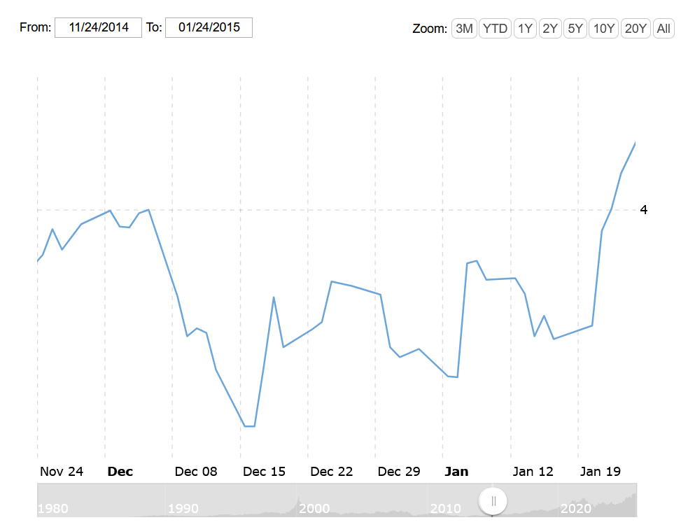

Lessons Learned
The attack that Sony faced could have been prevented or at least mitigated by employing adequate cybersecurity measures. The data that was stolen and leaked by the Guardians of Peace, such as social security numbers, usernames, and passwords, should have been encrypted. In the case of Wiper malware, CrowdStrike suggests that “one of the first lines of defense against wiper attacks is recognizing early warning signs. Unusual system behavior may indicate that a wiper attack is in progress.” The unusual behavior could be changes to files, unauthorized access to workstations, strange emails, and a slow computer. In order to spot these erroneous behaviors, Sony could have employed monitoring capabilities to detect and respond to the virus. Although monitoring is a strong tool, it is nothing without having a strong incident response plan. Since Sony had to call in the help of the FBI and Mandiant, their response plan was not enough. Although the virus’s damage was unprecedented, having a strong response could have prevented the need for additional aid. One final line of defense Sony could have employed was backups. Backups are arguably the most important line of defense in the case of ransomware attacks or wiper attacks. Having backups would have allowed Sony to restore their wiped data.
Final Thoughts
The Sony attack in 2014 is still a topic of discussion and a valuable case to study. In 2018, Park Jin Hyok was issued an arrest warrant for “one count of conspiracy to commit wire fraud and one count of conspiracy to commit computer-related fraud (computer intrusion) in a federal criminal complaint. (FBI, 2018)” The main consensus is that North Korea was in fact behind the attack. The hack was a valuable lesson that Sony had to learn and was even a political lesson as North Korea pressured the company to not release the film, which could be considered an attack on American freedom.

Works Cited
BBC News. (2014, June 25). North Korea condemns Sony film about Kim Jong-un. https://www.bbc.com/news/world-asia-27989838

CBS News. (2014, December 15). James Franco, Seth Rogen laugh off massive Sony hack on “SNL”.
https://www.cbsnews.com/news/james-franco-seth-rogen-laugh-off-massive-sony-hack-on-snl/

CrowdStrike. (2023). What are wiper attacks? https://www.crowdstrike.com/en-us/cybersecurity-101/malware/wiper-attack/

Federal Bureau of Investigation. (2014, December 19). Update on Sony investigation. https://www.fbi.gov/news/pressrel/press-releases/update-on-sony-investigation
IMDb. (2014). The Interview. https://www.imdb.com/title/tt2788710/

Los Angeles Times. (2014, December 7). Timeline: After the hack—Sony Pictures’ road to recovery. https://www.latimes.com/entertainment/envelope/cotown/la-et-ct-sony-hack-chronology-html-20141207-htmlstory.html

Macrotrends. (2025). Sony stock price history. https://www.macrotrends.net/stocks/charts/SONY/sony/stock-price-history

The Guardian. (2014, December 18). Sony hack: The plot to kill “The Interview”—A timeline so far. https://www.theguardian.com/film/2014/dec/18/sony-hack-the-interview-timeline

Wired. (2014, December 17). Sony hack: What we know. https://www.wired.com/2014/12/sony-hack-what-we-know/

The Verge. (2014, December 2). Sony memo warns employees attackers may release stolen data. https://www.theverge.com/2014/12/2/7323847/sony-pictures-hack-memo-employees

